Project 6 Polynomials and Rectangles: Rectangles Images

Rectangle A
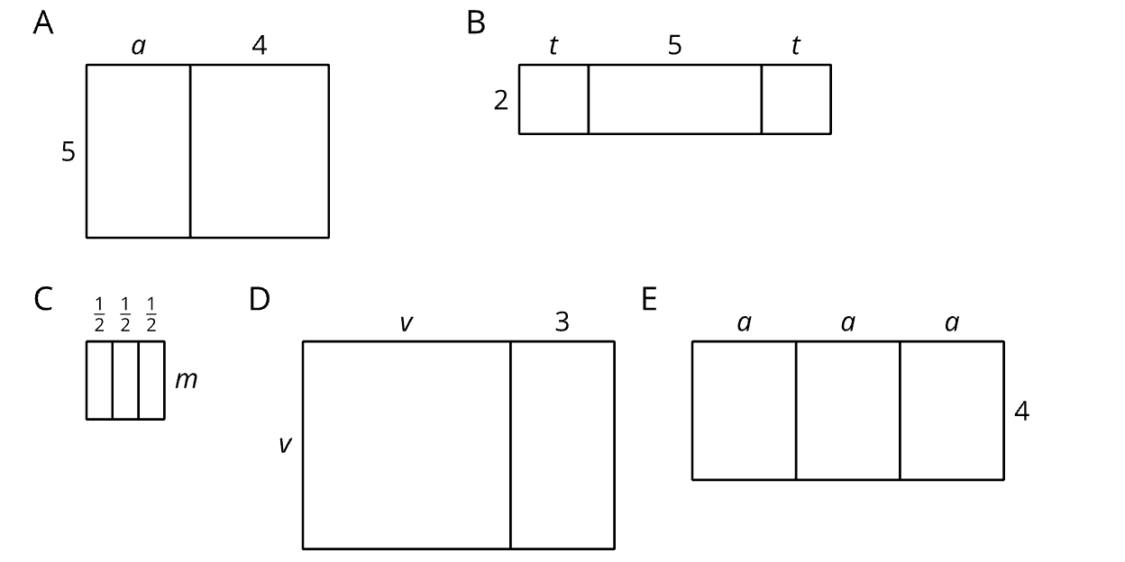

Rectangle B


Rectangle C


Rectangle D



Rectangle E



